The human right to adequate housing is the right of
every woman, man, youth and child to gain and sustain
a safe and secure home and community in which
to live in peace and dignity.

Miloon Kothari, former United Nations Special Rapporteur on adequate housing

INTRODUCTION
The Global 16 Days Campaign was launched by the Center for Women’s Global Leadership (CWGL) at its first Women’s Global Leadership Institute in 1991, has been used worldwide to call for the elimination of gender-based violence (GBV). It is run annually from November 25 (International Day Against Violence Against Women) to December 10 (International Human Rights Day).
In 2020, the Campaign will increase its efforts to amplify the voices of women workers in the informal economy while continuing to call for the ratification of ILO Convention 190 and to end all forms of GBV in private and public spaces.
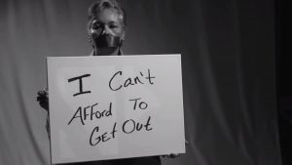
While we believe in the importance of economic empowerment as utmost importance towards gender equality and that economic abuse by an intimate partner is also a form of violence, we are convinced that the immediate need of a domestic violence survivor is also a safe home. While some of them may be able to stay safe in their own home, others would require emergency shelters and transitional housing programs before being to regain independent housing.

Homelessness: A human right violation
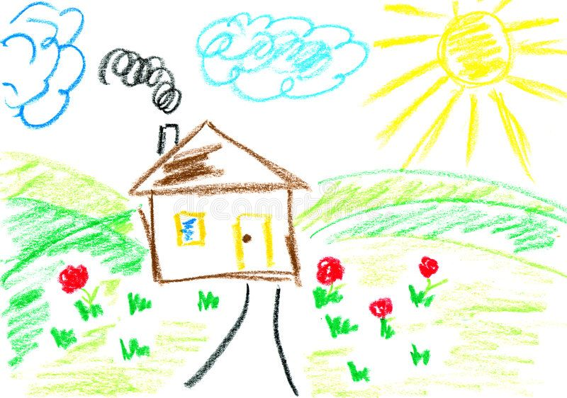
In addition to the Universal Declaration of Human Rights (art. 25), the most authoritative international recognition of the right to adequate housing as a component of the right to an adequate standard of living is contained in the International Covenant on Economic, Social and Cultural Rights, which states that States parties “[…] recognize the right of everyone to an adequate standard of living for himself and his family, including adequate food, clothing and housing”. According to the report ‘Women and the right to adequate housing’ published by the Office of the High Commissioner of the United Nations Human Rights, “The lack of protection of women’s right to adequate housing can make them more vulnerable to domestic violence.
Denial of secure tenure through gender-biased laws, policies, regulations or customary laws and practices can also make women more vulnerable to domestic violence. If women do not enjoy security of tenure, they may not be able to leave an abusive relationship. They may have to make a choice between becoming homeless—often with their children—or facing physical and psychological violence at home. When shelters for battered women are not available, many women who leave their homes become vulnerable to homelessness and may suffer further violence as a result. Even if women do have security of tenure, their inability to remove the perpetrator from the house—because there is no family, community or State support, or specific legislation providing for this—seriously limits their ability to escape a violent relationship.
As mentioned above, in the absence of secure tenure, domestic violence can greatly increase women’s vulnerability to homelessness, especially when they are not protected by law enforcement officials or by the legal system itself. Some of the pervasive cultural assumptions about a woman’s need to “leave” a violent household—as opposed to the need to remove a violent partner—undermine women’s enjoyment of the right to adequate housing.
In Mauritius, domestic violence is also one of the leading causes of homelessness for women and their children. The lack of safe and affordable housing has been reported as a main barrier for victims of domestic violence to leave their abusive partner. Without a home, they are left with no choice than to be admitted to emergency shelters where they can stay for a limited period of time. However where do they go when leaving the shelters? Most of them cannot work without being safe in a house or are not eligible to any loan facility that could help get their own house. They are also faced discrimination when trying to rent a house which most of the time they do not have the financial mean to pay for.

(See answers to the interviews carried out by Passerelle with 200 survivors of Domestic Violence)

THE PROJECT
The project consists of providing safe housing opportunities to survivors of domestic violence through transitional and permanent housing.

- Transitional housing Programs
While Passerelle’s emergency shelter addresses a survivor’s immediate safety needs and is a relief to victims of domestic violence, we found it important to also provide transitional housing since three years.
We currently have two transitional houses located in the surroundings of the shelter where same supportive services are provided. They are safe, affordable option that empowers survivors to begin rebuilding their lives and helps them prepare for permanent housing.
It is based on a communal model housing where 3 to 4 survivors live under the same roof with their own private bedrooms and shared living spaces and kitchen. The rental cost is paid by the association and they contribute to overhead costs and food expenses.
The beneficiaries can stay up to 12 months which give them the time to be financially independent, achieve stability and meet their goal to long-term housing.
We would now like to introduce the ‘Scattered-site model’ which mainly for women with children, where it is more difficult to share a common house.
It is a secured house in the community that is rented by the organization and other expenses by the family and close monitoring and support is provided to the family for a period up to 12 months.

According to the report of Advisory Committee on Reinforcement of Framework for Protection against Domestic Violence, presented by Pierre Rosario Domingue since November 2014
Page 39:
(d) Affording Better Protection, Support and Assistance to Victims
42. Victims/Survivors of domestic violence have experienced physical, sexual, psychological or economic violence, and thus require comprehensive care, both short-term and long-term. They should be protected from perpetrators in order to avoid the recurrence of further violence and ensure that victims receive adequate and timely services. Medical (including psychological) interventions and social support are essential in protecting victims of domestic violence. Having reported incidents of violence, victims/survivors may need medical and psychological treatment, shelter or alternative accommodation and in the case of child victims/survivors, special attention from child protection services and agencies dealing with child witnesses. Counselling and other support services offer victims options to stop the violence; prevent its recurrence; treat the trauma (mental and physical); and understand, address and challenge the factors responsible for the violence.\ Referrals and legal advice provide victims with information on their rights and assistance in accessing these rights.

- Permanent Housing Opportunities
In order to truly help and support survivors to definitely flee violence and not go back to their abusive partners just because they do not have a house, it is important to provide for a flexible housing system and increase the availability of affordable housing.
Apart from emergency and transitional houses, permanent housing options shall also be available.
Survivors of domestic violence shall be considered as part of the hardship cases programme by the National Housing Development Company Limited (NHDC) and the National Empowerment Foundation (NEF) to provide opportunities to them in having access to affordable safe houses.
Through fundraising activities and with the help of donors, Passerelle will be helping women that became homeless due to domestic violence through registration procedures to become a house owner and help them with the minimum deposit to be paid and they will pay for the monthly fees.
Then they will benefit from social support and empowerment programme from the association.

BUDGET BREAKDOWN
ITEM | UNIT | COST PER UNIT | No. of Units | TOTAL COST
Rental of 3 Transitional Houses (Communal Model Housing) | Rental fees for 3 Houses | 50,000 | 12 | 600,000
Rental of 5 transitional Houses (Scattered Model Housing) | Rental fees for 5 houses | 40,000 | 12 | 480,000
Fees for permanent Housing | Deposit amount per beneficiary | 100,000 | 16 | 1,600,000
Administrative and Finance Coordinator | Monthly salary (All inclusive) | 18,000 | 13 | 234,000
Social Worker and on field officer | Monthly salary (All inclusive) | 18,000 | 13 | 234,000
Support and Training Cost | All year round |  |  | 120,000
Audit and reporting Fees | Package | 25,000 | 1 | 25,000
Administrative Fees |  |  |  | 180,000
Contingency Expenses |  |  |  | 27,000
TOTAL |  |  |  | 3,500,000

THE 16 DAYS CAMPAIGN ACTIVITY

The 16 days activism calendar starting on the 25th of November 2020 and ending on the 10th of December 2020 will consist of a national awareness and fundraising event around the island.
For 16 consecutive days, a zumbathon will be organized in 16 different regions. The idea is to gather both men and women in a nice area for some Zumba time but most importantly to create awareness about the role of each citizen to act against domestic violence. Each event will last about two hours per day.
In parallel a fund-raising event will be organized through the platform crowdfund.mu for the permanent housing part of the main project. Thus the goal is to fundraise about Rs 1,600,000 to contribute in helping 16 survivors of domestic violence to get their own house through the NHDC.

16 Faces
16 inspiring Women Leaders would be supporting the event each day by participating in at least one of the Zumbathon event as main ambassadors and by delivering a strong and powerful message to encourage everybody to support actions aiming to end domestic violence.

HOW CAN YOU SUPPORT THE ZUMBATHON?
- By helping the team to organize the whole event
- By proving a suitable venue for at least one event
- By sponsoring T-shirts, Sound System, Water bottlers, Posters and Flyers
- By joining in for one of the event for the Zumba session and awareness campaign
- By spreading the message and inviting you friends to support
- By donation through the online platform crowdfund.mu to support the project
CONCLUSION
Stay Home, Stay Safe. These are words we’ve been hearing a lot during this difficult Covid-19 period. What about those that do not have a house?
During the lockdown period, 467 cases of domestic violence has been reported to the authorities. 467 persons that did not feel safe at their place and needed help to flee from a violent situation.
Some of them, not to say most, are unfortunately back to their abusive partners because they did not have any other place to go. In worst case scenarios, there are women living on streets.
Unfortunately, survivors of domestic violence continue to be punished for the actions of their abusive partners as they are those that often need to leave the house with the children.
Let’s join hands in supporting them those courageous survivors in keeping safe.
There’s no place like a home…

